EXPERIMENT 9

Aim: To develop a user interface prototype for a GSM service using Figma.
Procedure:
- Open Figma and create a mobile-sized frame.
- Add a title such as “GSM Mobile Services.”
- Create buttons for voice calls, SMS, contacts, and network status.
- Add a signal indicator and battery icon.
- Design separate screens for calling and messaging.
- Connect the screens using Prototype mode.
OUTPUT:
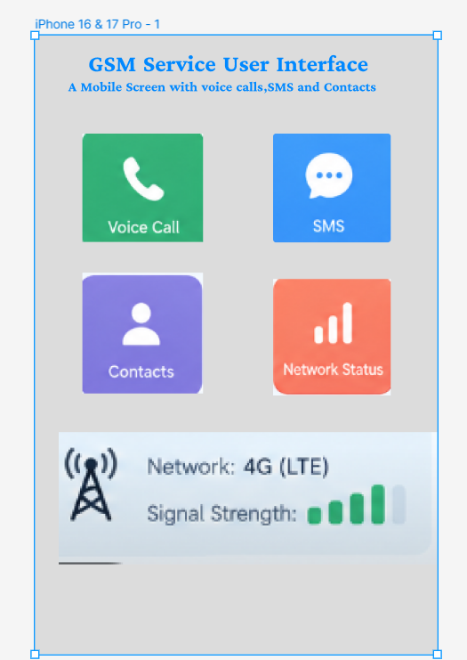

FIGMALINK:
https://www.figma.com/design/ED1qcVpNfWi2Zuft4amJyZ/Untitled?node-id=56-36&t=zih8IyL283jodQsH-0

RESULT: `A GSM service user interface prototype was developed successfully using Figma.

